PARISH NEWS
The Deverills & Crockerton

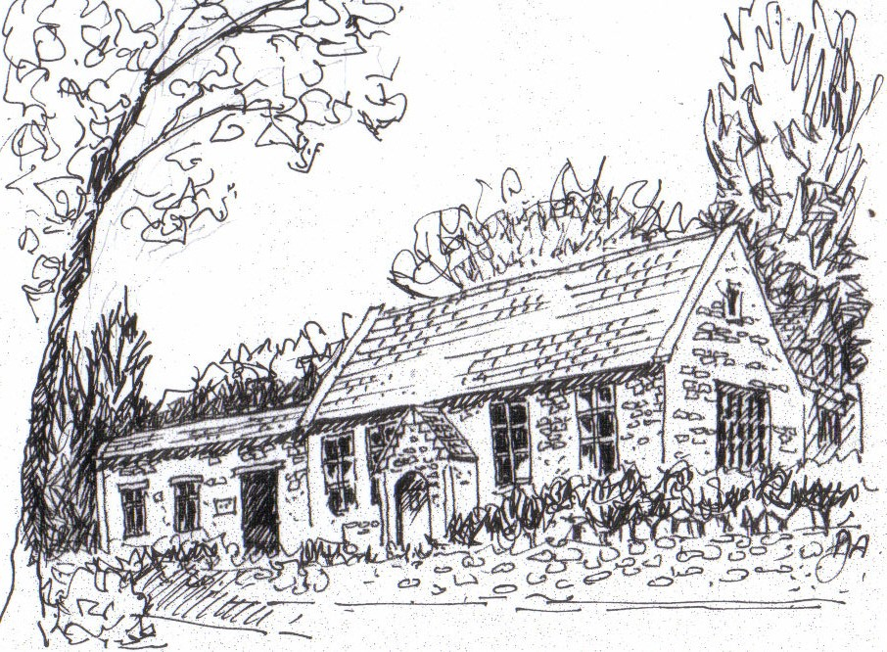

Crockerton School by Pat Armstrong
September 2010

Look inside for local information

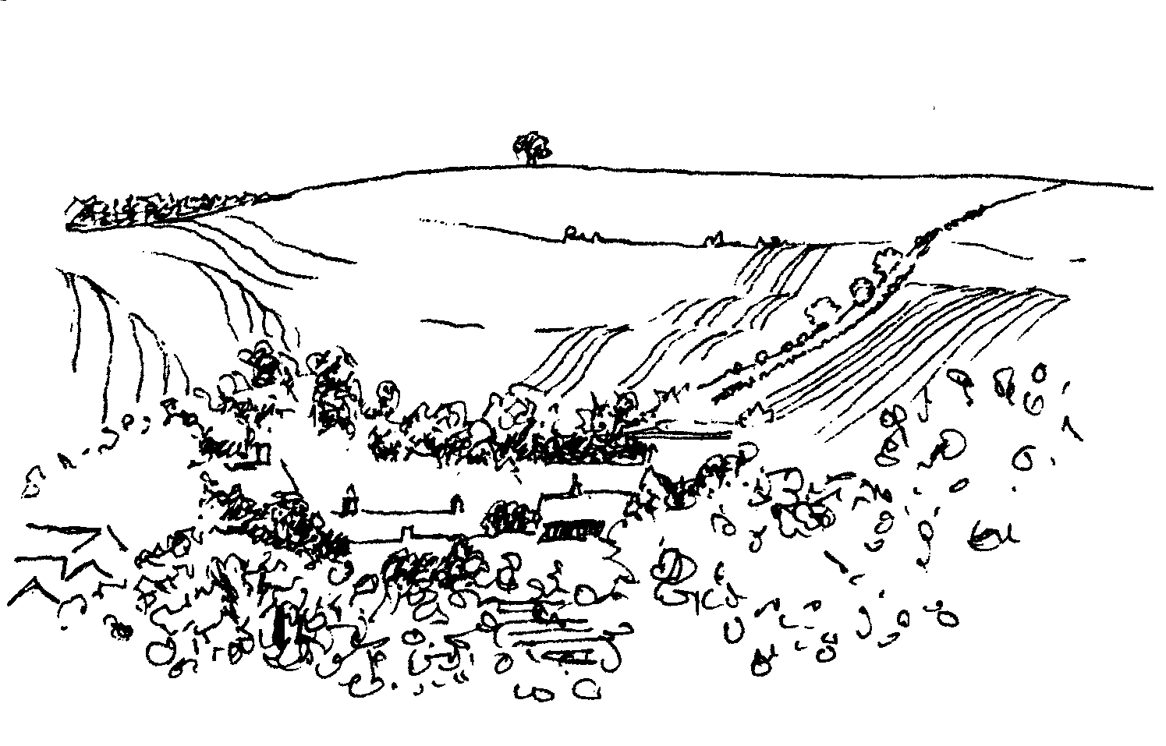
-2-

Back to church Sunday
26th September
Come and join us
You will be very welcome at our service
Longbridge Deverill Church at 10.30 am

MUSIC IN THE DEVERILLS
Friday 10th September 8.00 pm
4+1 Jazz band (New to the Deverills)
St Michael’s Church, Brixton Deverill
Tickets £10 (inc. glass of wine) call 840877
Pre - concert supper 6.30 pm
Manor House Brixton by kind permission of Johnny & Pony Burridge
Tickets £10 (inc. glass of wine) call 840877
Cheques payable: PCC Deverills & Horningsham
(profits to the Deverill Churches Fabric Fund)

SATURDAY 11TH SEPTEMBER
SUPPORT
THE WILTSHIRE
HISTORIC CHURCHES TRUST
TO TAKE PART
PLEASE CONTACT
JUDY MUNRO 844385

JUNIOR CHURCH & CRECHE

Longbridge Deverill Village Hall
Fourth Sunday of the Month

Starting 26th September

10.30 until 11.30 am (during church service)
6 months to 11 years - everyone welcome
For information contact Victoria Hamilton 841204

Back to church Sunday
26th September
Come and join us
You will be very welcome at our service
Longbridge Deverill Church at 10.30 am

MUSIC IN THE DEVERILLS
Friday 10th September 8.00 pm
4+1 Jazz band (New to the Deverills)
St Michael’s Church, Brixton Deverill
Tickets £10 (inc. glass of wine) call 840877
Pre - concert supper 6.30 pm
Manor House Brixton by kind permission of Johnny & Pony Burridge
Tickets £10 (inc. glass of wine) call 840877
Cheques payable: PCC Deverills & Horningsham
(profits to the Deverill Churches Fabric Fund)

SATURDAY 11TH SEPTEMBER
SUPPORT
THE WILTSHIRE
HISTORIC CHURCHES TRUST
TO TAKE PART
PLEASE CONTACT
JUDY MUNRO 844385

JUNIOR CHURCH & CRECHE

Longbridge Deverill Village Hall
Fourth Sunday of the Month

Starting 26th September

10.30 until 11.30 am (during church service)
6 months to 11 years - everyone welcome
For information contact Victoria Hamilton 841204

Back to church Sunday
26th September
Come and join us
You will be very welcome at our service
Longbridge Deverill Church at 10.30 am

MUSIC IN THE DEVERILLS
Friday 10th September 8.00 pm
4+1 Jazz band (New to the Deverills)
St Michael’s Church, Brixton Deverill
Tickets £10 (inc. glass of wine) call 840877
Pre - concert supper 6.30 pm
Manor House Brixton by kind permission of Johnny & Pony Burridge
Tickets £10 (inc. glass of wine) call 840877
Cheques payable: PCC Deverills & Horningsham
(profits to the Deverill Churches Fabric Fund)

SATURDAY 11TH SEPTEMBER
SUPPORT
THE WILTSHIRE
HISTORIC CHURCHES TRUST
TO TAKE PART
PLEASE CONTACT
JUDY MUNRO 844385

Coffee, Cards and Chat
Come and enjoy looking at the new range of cards,
ribbons, wrapping paper, and other exciting items
displayed by John and Maddie Goodden
in the Upper Deverills Village Hall on Thursday 19th February
between 10.30 and 12.00 noon - everyone is welcome
Donations will be made to the hall and the church



JUNIOR CHURCH & CRECHE

Longbridge Deverill Village Hall
Fourth Sunday of the Month

Starting 26th September

10.30 until 11.30 am (during church service)
6 months to 11 years - everyone welcome
For information contact Victoria Hamilton 841204

-3-

The Rector writes:
What a summer we have had! Wonderful sunshine, warm days, blue skies, perhaps not quite as much rain as farmers and gardeners would have liked, but good nevertheless. Many folk have managed to get away for a well-earned break, and the rest of us have enjoyed a ‘holiday at home’. With the start of September, there is a real feeling of movement towards the end of the year. (I won’t mention the C word, but already advertisements for celebration meals are in the local press!)
With the dry weather, there has been much activity in the locality, as farmers work long days, harvesting their crops. The landscape has been full of beautiful colours, swathes of green and gold as far as the eye can see. How very blessed we are to live in such a splendid part of the country.
That awareness has been particularly strong in the last few weeks, as images of very different weather conditions have been brought into our very homes through television and newspapers. Devastation by floodwater always seems so dreadful. Whole communities washed away, the few possessions which it is possible to salvage, damaged, and increasing dangers from water-born disease are the dominating conditions for many Pakistani and Chinese people. To live with the knowledge that flooding is an ever-present danger is beyond what most of us can imagine. But the indomitable human spirit is rarely completely squashed.
In all sorts of situations, lives that have been shattered are rebuilt. Burgeoning hope for the future brings courage and resolve. Good things rise, Phoenix-like, from the ashes of destruction, broken relationships and shattered lives. That seems to me to be an important characteristic of our Christian heritage. Even in the darkest times, hope is present. God is made known to us in the ministrations of family, friends and the wider community. Even when the world seems dark, the light of the gospel has the potential to carry us through, and to bring us to places of growth once more.
In generosity, we are all able to help those who are in dark places right now, financially as we reach out to people on the other side of the world, or with our time, skills and friendship to those closer to home.
Whether you are ‘givers’ or ‘receivers’, may the light of the gospel shine for you all.
Norma Payne
P S If you have not been to church for a while, and would like to join us for worship, why not come on Back to Church Sunday ~ an ideal opportunity ~ 10.30 am at Longbridge Deverill, 26th September. A warm welcome awaits.

-4-

CROCKERTON VILLAGE COMMITTEE
CYCLE RIDE
Friday 17th September at 6.00pm
Please join fellow villagers for a fun evening cycle ride
Starting & finishing at Bath Arms - all ages, abilities welcome
MacMillan Cancer Support
World’s Biggest Coffee Morning
Friday 24th September 10.00 am – 12.00 noon
Come and support us at Lakeside Garden Centre
Cakes, Raffle, Tombola etc - donations gratefully received
Further information from Janet Budgen 218203

Salisbury Theatre Club Trips
Monday 13th September
A Voyage Round My Father by John Mortimer
NB: There will be NO trip in October
Monday 15th November
The Picture by Philip Massinger
The cost is £19.00: theatre seat £14.00 (please note change) coach trip £5.00
Please book early to ensure tickets, payment in advance to Mary Stewart Cox
Tel 840877 at Longmead, Brixton Deverill, Warminster BA12 7EJ
Coach leaves Kingston Church 6.10 pm and collects through the Deverills
Performances begin at 7.30 pm

Creative Textile Workshops
Longbridge Deverill Village Hall
10.00 am - 3.00 pm
Fridays: 10th September, 1st October, 22nd October, 12th November, 3rd December
For further details and fees please contact Lynn Creighton 840387 or email: lynncreighton@ymail.com

-5-

The Deverills Chamber Choir

The choir was formed in May 2009 and consists of people from the Deverills and Warminster who enjoy coming together to sing a variety of music, from sacred and secular, to comic and contemporary, just for fun or for weddings and services. No previous experience is necessary; training is given, so just bring a good ear and love of singing! We meet on Fridays at 7.30 pm in Longbridge or Kingston Deverill. For more information please contact Claire Johnson 01963 33592 or 07967 609520.
Our next meeting will be on Friday 3rd September at 7.30 pm at Kingston Deverill Church. We welcome new members, come along and sing with us!
Cast on Club
We will be resuming our meetings twice a month, on Wednesday 8th September and Wednesday 22nd September from 2.00 – 4.00 pm, please note a different day and time. This month we will meet at Judy Munro’s (844385) house, Whitepits Lodge, Kingston Deverill. Previously we have been making items for the premature babies at Salisbury hospital, which we can continue to do, but you may prefer to make something for yourself or for Christmas presents. If you would like to join us please come along bringing with you needles, wool and a pattern of something you would like to make. We look forward to seeing you.
The Deverills Cricket Club
Home matches take place on the cricket ground by the Upper Deverills Village Hall starting from 2.00 or 2.30 pm, please come along to watch and support us. The last home fixture is on: Sunday 12th September. If you would like to join the club please do call Peter Child 01963 34593 or Jamie Fagan 844123/ 07796 698180.
Deverill Valley & Crockerton Women's Institute
Out meeting this month will be on Monday 13th September at 7.30pm at Longbridge Deverill Village Hall and Mike Pope will be speaking on ‘How Larkrise to Candleford was filmed at Hatt Farm’. This will be followed by tea, biscuits, a raffle and an exhibition of Harvest Supper table decorations. If you would like to know more about the WI in the Deverill Valley please contact Julie Wallder on 213142. You would be very welcome to join out meeting.
Deverill Valley & Crockerton WI celebrates 90 years of WIs in the Deverill Valley this year. Were you, your Mother, Aunt or Granny ever a local WI member? We are planning an exhibition during November 2010 to show achievements and community involvement of past members during nine decades of great change. If you know the whereabouts of items like photos, certificates, craftwork, news cuttings that we may borrow, or can tell us stories about WI social activities, we would love to hear from you. Please phone Jill 840209.

-6-

Save the Children
Cream teas and garden open
This will be at Mill Farm, Hill Deverill on Sunday 26th September from 3.00 pm - 6.00 pm. There will be cakes and plants for sale as well as other interesting items. Come and enjoy a relaxing afternoon in the barn or garden.
Anne Hurd
Postcards for Sudan
Summer holidays are coming to an end and on many mantelpieces lurk postcards sent by family and friends. Before they gather dust, how about recycling them! The Sudan Church Association has raised over £60,000 in the last 5 years from old postcards and I should be glad to send them on to Len Whitaker who says that on average every postcard is worth 5p to him!
By the way, whilst on the subject of cards for Sudan, please remember that remade Christmas cards will be on sale very soon; in fact I have a number of boxes of them already at 30p each, having started to make them in January! And thank you for saving me your old cards, I have made good use of them.
Jane Yates 844374

Curry /Casino Evening
Friday 8th October
At Bradley House, Maiden Bradley
In aid of

SSAFA Forces Help 125th Anniversary
Tickets £25 pp. For details and to book, contact:
melvynthomas@btinternet.com or call 844830/302555

Gala Dinner Night
Saturday 9th October
At Bradley House, Maiden Bradley
In aid of

SSAFA Forces Help 125th Anniversary

Tickets £75 pp. For details and to book, contact:

melvynthomas@btinternet.com or call 844830/302555




-7-
Thursday Group
Mother and Toddlers will restart on Thursday 2nd September, from 10.00 - 11.30 am, at Longbridge Deverill Village Hall, after their summer break. Some of the older children have left us to go on to their new school and we wish them well. The group is for children under 5 years. Parents, grandparents or anyone looking after children are most welcome to come along at any time. If you would like to know more, please ring Sylvia Titt 214825.
Longbridge Deverill Village Hall
The hall has recently been inspected by Wiltshire Council for Health & Hygiene. We are pleased to say that we have been given a Five Star rating, the highest award. Thank you to everyone who helps to keep the hall up to standard and to everyone who has given money and, of course, to those who support the events at the hall so that we are able to purchase all the equipment and to run the hall in the way to achieve this standard.
Please note the following dates and come along to enjoy and support these events:
Forthcoming Events
Harvest Supper Saturday 9th October
Christmas Entertainment Saturday 11th December
Pat Wood
Upper Deverills Village Hall
Please note in your diaries the following dates for our Autumn activities, we hope you will be able to come along to enjoy them and support the committee.
Forthcoming Events
Harvest Supper Saturday 16th October
Quiz Night Friday 12th November
Curry Lunch Sunday 14th November
Eddie Mirzoeff Evening Friday 3rd December
Village Carol Service Sunday 19th December
Richard Cousens
Pilates
A new Thursday afternoon Pilates class will start in November at Upper Deverill Village hall. Due to the success of the two Thursday morning Pilates classes that have been running at the hall since April (both are now full) there is an opportunity to hold a lunchtime class from 1.00 - 2.00 pm starting after the October half term. The start date will be Thursday 4th November. For more details and to book your place, please contact Emma Healey 01373 814744 / 07929 517474 healeydel@aol.com. (Other classes resume on Thursday 9th September.)

-8-

SERVICES PARISH OF DEVERILLS & HORNINGSHAM
Contact the Clergy
Please contact Norma Payne (841321) or Di Britten (01373 832515) if anyone is housebound and would like communion or a visit at home;
or if someone is ill and needs our prayers; or to discuss any church matter.
Administrator phone 215460 or email: churchofstdenys@btconnect.com

The Deverills & Horningsham Register
Baptism
Poppy Mabbutt at Brixton Deverill on Sunday 1st August
Funeral
Ann Dufosee at Longbridge Deverill on Wednesday 4th August

Sunday Trinity 14
5th September Brixton 8.00 am Holy Communion 1662
Longbridge 10.30 am Morning Worship
Horningsham 6.30 pm Evensong
Sunday Trinity 15
12th September Kingston 10.30 am Holy Communion
Horningsham 11.15 am Holy Communion
Sunday Trinity 16
19th September Longbridge 8.00 am Holy Communion 1662
Brixton 10.30 am Holy Communion
Sunday Trinity 17
26th September Longbridge 10.30 am Holy Communion
Horningsham 11.15 am Morning Prayer
Kingston 6.00 pm Evensong
Sunday Trinity 18
3rd October Kingston 8.00 am Holy Communion 1662
Longbridge 10.30 am Harvest Festival
Horningsham 6.30 pm Harvest Festival
& Back to Church Sunday

Tuesday, Wednesday, Thursday, Friday Longbridge 8.30 am Prayers
Wednesday Longbridge 10.15 am Holy Communion
Parish Prayer Group meeting - Deverills and Horningsham
Tuesday 7th September 7.00 pm to 8.00 pm at Mary Royall’s house (840338)

-9-
SERVICES PARISH OF CORSLEY & CHAPMANSLADE

IVY HOUSE - ST DENYS RETREAT CENTRE
Wednesday 15th September
House Quiet Day with Jeanne Blowers

Friday 24th September
Garden Quiet Day
For bookings & information please ring 214824
Sunday Trinity 14
5th September Corsley 9.30 am Holy Communion
(Note change of time)
Sunday Trinity 15
12th September Chapmanslade 9.00 am Holy Communion
Temple 11.00 am Morning Prayer
Sunday Trinity 16
19th September Chapmanslade 9.00 am Holy Communion
Corsley 6.00 pm Holy Communion
Sunday Trinity 17
26th September Temple 9.00 am Holy Communion 1662
Corsley 10.30 am Parish Service & Baptism
Sunday Trinity 18
3rd October Corsley 9.30 am Holy Communion

Church Cleaners for September
Kingston – Judy Munro & Sara Fagan
Brixton – Jo Greenwood & Penny Marsh
Longbridge - Monday 6th September 9.30 - 10.30 am - all helpers
Church Flower Arrangers for February
 | Kingston | Brixton | Longbridge
5th Sept | Maddie Goodden | Mrs Sutton | Jane Robbins
12th Sept | Anne Wiltshire | Mrs Sutton | Jane Robbins
19th Sept | Anne Wiltshire | Mrs Hammick | Mary Royal
26th Sept | Liz Gatt | Mrs Hammick | Mary Royal

-10-

Recipe of the Month
Sponsored by Maiden Bradley Community Shop (844206)
Raspberry Bakewell Picnic Cake
Ingredients
140g ground almonds 2 eggs
140g butter, softened 250g raspberries
140g golden caster sugar 1 tsp vanilla extract
140g self-raising flour 2 tbsp flaked almonds
Icing sugar to serve
Method
Heat oven to 180C/160C gas 4
Prepare a deep 20cm loose-bottomed cake tin
Blitz ground almonds, butter, sugar, flour, eggs, vanilla extract in food processor
Spread half the mixture over the bottom of the cake tin
Scatter the raspberries over the mixture, then spread the remaining mixture on top
Scatter with flaked almonds and bake for 50 mins until golden
Cool, remove from the tin and dust with the icing sugar to serve
Wine - Cape Crusaders
I fell head over heels when I first visited South Africa back in 1998 and since then I’ve been lucky enough to go back many times visiting both industrial-sized and boutique wineries. As impressive as the state of the art wineries are, it is always refreshing to discover a small estate off the beaten track, many of which have beautiful guest houses for the cost of a Travelodge. South Africa has changed an awful lot in the 12 years since that first visit but one thing that has not changed has been the consistency with which they can produce great wines at good prices. Traditionally known as the home of Chenin Blanc and Pinotage (a cross between Pinot Noir and Cinsault developed by the South African wine industry back in the early 20th century), the Western Cape is now a top producer of Sauvignon Blanc and Shiraz, the Sauvignon benefiting from the cooling sea breeze that blows in from the Atlantic and the Shiraz achieving lovely ripe flavours from the reliably warm sun. If you can’t drink a bottle sitting overlooking the vineyards and the distant sea at Gordons Bay, try one of these in your own back garden: Lyngrove Estate Sauvignon Blanc 2009 - on a vine-covered hill just outside Stellenbosch, Lyngrove has a great guest house and pool. (There is even a sherry nightcap provided in your room.) This Sauvignon has been a Co-op staple for years now and has mouth-watering lime and passion fruit flavours, perfect on its own or with smoked chicken and mango salad. Co-op £5.76; Zalze Shiraz Mourvedre Viognier 2009 – an interesting blend with a dollop of a white variety to boost the fruit, this is rich, silky and ripe with blackberry and forest fruit flavours. Savour it with your barbecued lamb. Waitrose £6.49.
Elizabeth Wilson

-11-
Where have you been?
We did more than our fair share of eating out in early August; this was because we had one of our family staying with us – a young man with a healthy appetite! We took the opportunity to try out a few pubs we had been thinking about trying for some time. The first was to The Dove at Corton (01985 850109). We had heard that it had changed hands last autumn, in fact the last tenant’s lease was up and the owner had taken it back under his own auspices. We visited on a Saturday night when there were relatively few diners in the pub but it does have a number of dining areas and some people were eating outside so people were spread around. My husband and I started with soup, which was good; our young guest had pate, which he thought ‘outstanding’ followed by a burger which he also thought ‘excellent’ and I got the feeling he was a bit of a connoisseur! I had Moroccan lamb which was good but a little too spicy for my taste and my husband had a pork dish which he considered very good indeed. The ambience on that particular evening was slightly impaired by some people who came in just to drink at the bar. However, the waiting staff were efficient and pleasant and the food very good, the portions generous and well- priced. Why not give it a try for lunch? Dogs are welcome in the bar dining area.
On a particularly fine Monday, we decided to walk over to Mere and try out The George (01747 860427). This pub also changed hands in the autumn of last year, inside the décor is smarter but not very different from how it was before. We were in the market for substantial snack lunches having just walked for a couple of hours and The George did not disappoint. The chaps each had a panino, which they thought very good; I had ham, egg and chips which was very good indeed – excellent ham and hand cut chips. We think it might be worth going back and trying something more substantial, perhaps during the Mere Literary Festival in October.
Finally, after our visitor left, we treated ourselves to a meal at The Bath Arms, Horningsham (01985 845187). On the night we visited the pub it was not particularly busy and we were quickly shown to a table in the dining area. The food was very enjoyable; I had a goats’ cheese and beetroot starter (the latter sourced from Simpsons Seeds, located in the village, reinforcing their claim to use local foods) and my husband had mackerel pressed in a jelly – I tasted it and it was delicious - mine was good but he definitely picked the winner! We both enjoyed our choices for main course, though we didn’t order any side dishes which meant the portions were on the small side. The service was very prompt and efficient. I did not like the piped music in the dining room and the maître d’ immediately offered to turn it off (I declined because the other half dozen diners may have been enjoying it!). We also queried the blinds being low on a fine summer’s evening – a problem with sunlight in peoples’ faces – and again an offer was immediately made to lift them up a bit. All in all we enjoyed our visit. Interestingly the bill for 2 of us came to almost the same as that for 3 of us at The Dove (including similar drinks).
If you have somewhere to recommend, please send your suggestions to me by email at farthings.kd@btinternet.com or to Farthings, Kingston Deverill.
Trish Shuler

-12-

Donations of Paper
Thank you very much to those who have previously donated paper for the Parish News, this helps to keep the printing costs down. Over 600 copies are produced each month and delivered to every house in the valley, providing a very important means of communication within our community. We would very much appreciate further donations of paper either to myself at Whitepits Lodge, Kingston Deverill, or to Les Wood (840535) who lives at Green Tiles in Hill Deverill. Thank you.
Judy Munro - Editor
Crockerton Village Committee
The Committee photograph taken by David Wiltshire on Sunday 4th July, to commemorate its 10th anniversary, is for sale at David Wiltshire's shop in Warminster for £5.00. He is very kindly donating all the proceeds from the sale of the photograph to the Committee.
Library Services
The home library service delivers books to your door. It helps people who can no longer use their local library due to poor health of frailty; a member of staff can talk to you about what you like to read and then visit your home with a library volunteer and a selection of books. Every few weeks, a library volunteer will call and exchange your books. You can borrow every kind of book, many in large print. Books on cassette, CD and ‘Playways’ (MP3 format) and music CDs. To find out more contact your local library or call 01225 713706.
Wiltshire’s Recycling Centres
The recycling centres typically re-use or recycle more than 75% of the waste that they receive. They are open every day 9.00 am - 5.00 pm, and until October additional hours on Wednesdays and Thursdays opening until 7.00 pm. Many, many items can be recycled including batteries: AA, AAA, spent rechargeable battery packs from laptops and DIY tools. Over 40% of all household waste is now recycled in Wiltshire.
The Wiltshire Bobby Van Trust
Protecting the Vulnerable
The Wiltshire Bobby Van Trust is a registered charity that has been supporting our communities for over 12 years. The charity offers a free security and fire risk assessment to elderly and vulnerable folk living in Wiltshire. They secure 1,300 homes a year. The Operator will upgrade locks, add window locks, door viewers etc to property free of charge plus give advice on how to remain safe at home. Do you know anyone over 60 or in a vulnerable position who would benefit from this support? If so, please call the office on 01225 794652.

-13-

Nature Notes
At last we have had some decent rain. You could almost hear the countryside breathe a sigh of relief, although it is far too late to do any good in improving crop yield. I am very surprised that anything has been able to grow with it being so dry. The scenery has started to change as fields get combined, straw baled and then the ground ploughed in readiness for the next crop. There is a feel of September in the air and summer on the wane. The last week has been decidedly cooler. Hopefully there will be time for the grass to recover and silage or even hay, if the weather allows, to be made for winter fodder. Our lawn has already ‘greened up’ and started growing again.
Birds seem to be breeding later this year. We have had young house sparrows and blackbirds still being fed in the garden. I can hear loud cheeping sounds coming from a nest box near the vegetable plot which I am pretty sure are young tree sparrows. Three of the house martin nests have young in them. I would expect these to be the last broods of the year. I think I heard some young swallows in the nest when I passed by the garage yesterday; once again probably the last of the season. The other morning we had a hen pheasant in the front garden with two very young chicks. I have not seen them since. I am hoping that they have survived but chicks of that size are very vulnerable. Later that same day I saw a stoat out next to the vegetable patch and thought later how a pheasant chick would be an easy meal for it. This stoat gave me a super play display jumping, tail chasing, tossing and turning. It ran towards me on several occasions coming quite close before backing away. I just kept as still and quiet as I could while it continued to have fun.
Whilst out walking recently I spotted a pair of hobbies, I heard them calling first, managed to get them in the binoculars and then watched as they passed food between them, male to female I presumed. The female then flew back to the woods above Shearwater, I would think to fairly well grown young in the nest. The food item was large enough to see through the binoculars and identify as ‘bird’ probably house martin or swallow. On the same walk I saw at least two spotted flycatchers in the lane. I was not sure if they were adults or youngsters; they did not stay still long enough! Also on the walk I saw a couple of beautiful small blue butterflies. Now I am not that good at butterflies, but I know they were males as they were blue, the females of ‘blue’ butterflies are brown. Looking at a guide I reckon they were either common or Adonis blue. I don’t think there are so many butterflies about this year. We have had small tortoiseshell, comma, peacock, red admiral and the ‘whites’ around but not as many as last year. I have not seen any painted ladies.
On a walk to Shearwater I found a bumblebee, red-tailed I think, dead on the ground and covered in mites. Bees are not doing too well, wild or domesticated. I am not sure if the wild bee colony in one of the beech trees is still active. I have not caught sight of any activity recently when walking by. We do so rely on bees for pollination in the production of our food. If their population crashes we will be in serious trouble.
Jane Trollope (written on 15th August)

-14-

LOCAL COUNCILS, SOCIETIES, GROUPS etc.
Longbridge Deverill and Crockerton Parish Council
Karen Manfield 215285 (Chair) Peter Whithey 840347 (Vice Chair)
Helen Few 840119 (Clerk) Thomas Minter 216909
Bill Hurd 840023 Elaine Pidgeon 212878
Julian Algar 840816 Graham Read 840296
Brian Marshall 214789
Upper Deverills Parish Council
Lady Felicity Wheeler 844683 (Chair) Ranald Blue 841374
Sarah Jeffries 213436 (Clerk) Robin Greenwood 840743
Sarah Fagan 844123
Wiltshire Councillor
Fleur de Rhé Philipe 213193

Wiltshire Council 0300 456 0100

Longbridge Deverill Village Hall Committee
Pat Wood 840535 (Chair) Julie Read 840655 (Secretary) Sylvia Titt 214825 (Caretaker)

Upper Deverills Village Hall
Richard Cousens 844970 (Chair)
Mandy Martyn 844320 (Secretary) John Lea 844325 (Hall bookings)

Crockerton Millennium Committee
Marion Thomas 213739 (Chair)

Pre-School Children and Parents ‘Thursday Group’
Sylvia Titt 214825 Pat Wood 840535

Deverill Valley & Crockerton W I
Ruth Sutton (President) Julie Wallder 213142 (Secretary)

Sir James Thynne Almshouse
Mrs Sue Jackson 840322 (Steward)

Deverills Cricket Club
Jamie Fagan 844123 Peter Child 01963 34593

Wylye Valley Tennis Club
Colin Singer 213696

Wylye Valley Flower Club
Mrs Hazel Yate 215617 (President) Mrs S Scott 216584 (Programme Secretary)

Wiltshire Wildlife Trust
Elm Tree Court, Long Street, Devizes SN10 1NJ www.wiltshirewildlife.org

Rural Community Beat Manager - Police Community Support Officers
PC Vicky Pegrum - PCSOs Ian Owen & Caroline Wright - 0845 408 7000

Hospital Transport Link Scheme 211655

-15-

F O R T H C O M I N G E V E N T S
Forthcoming Events
- Scottish Dancing Monday Evenings Aline Fry (841054)
- Tennis Coaching 9.30 am Tuesday Mornings Judith Hirons (845255)
- Bell Ringing at Longbridge Wednesdays 7.30 pm Richard Munro (844385)
- Hearing Loss Lip-reading Wednesdays Margaret Head (213259)
- Thursday Group resumes Thursday 2nd September See p7/14
- Deverills Chamber Choir Friday 3rd September See p5
- Longbridge & Crockerton Parish Council meeting 7.30 pm Monday
6th September at Longbridge Village Hall See p14
- Parish Prayer Group Tuesday 7th September See p8
- Cast on Club Wednesdays 8th & 22nd September See p5
- Creative Textile Workshops begin Friday 10th September See p4
- 4+1 Jazz Band Friday 10th September See p2
- Ride and Stride Saturday 11th September See p2
- Deverills Cricket Club Sunday 12th September See p5
- Salisbury Theatre Club Monday 13th September See p4
- WI Meeting Monday 13th September See p5
- Wylye Valley Flower Club ‘Room in the Garden’ Tuesday 14th September See p14
- Upper Deverills Parish Council meeting 6.30 pm Wednesday 15th September at Upper Deverills Village Hall See p14
- Ivy House & Garden Quiet Days Wednesday 15th & Friday 24th September See p9
- Crockerton Cycle Ride Friday 17th September See p4
- Macmillan Cancer Support Coffee Morning Friday 24th September See p4
- Back to Church Sunday 26th September See p2/3
- Junior Church begins Sunday 26th September See p2
- Save the Children Teas Sunday 26th September See p6
- SSAFA Curry/Casino Evening Friday 8th October See p6
- SSAFA Gala Dinner Night Saturday 9th October See p6

F O R T H C O M I N G E V E N T S
16-
PARISH OF DEVERILLS AND HORNINGSHAM
Contact the Editor and the Website
Parish News Editor: Judy Munro 844385
Contributions for the Parish News through my letterbox or
by post to Whitepits Lodge, Kingston Deverill, Warminster,
BA12 7HD or by Email: judymunro@tiscali.co.uk Thank you
Please remember the deadline is the 15th of every month

Website: www.deverills.org.uk
Email address: info@deverills.org.uk
Website manager: Kate Wilkinson 844998
Contents: Parish News with church services, Parish Register, Events,
Local news plus pictures and other information
Churches
SS Peter & Paul the Apostles Longbridge Deverill
St Michael the Archangel Brixton Deverill
St Mary the Virgin Kingston Deverill
St John the Baptist Horningsham
Rector
Rev Norma Payne, 6 Homefields, Longbridge Deverill 841321
Clergy
Rev Diana Britten, 69 Lane End, Corsley 01373 832515
Licensed Lay Ministers
Mr John Budgen 218203
Col Robin Chappell 212153
Churchwardens
Mrs Elisabeth Atkinson (Longbridge Deverill) 212129
Mrs Mary Stewart Cox (Brixton Deverill) 840877
Major Mike Tulloch (Kingston Deverill) 844381
Mr Tim Moore (Horningsham) 844336
PCC Treasurer Mr David Stratton 844549
PCC Secretary Mr Nigel Poole 840902
Church Electoral Roll Officer Major Mike Tulloch 844381
Parish News Editor Mrs Judy Munro 844385
Organist Mr John Budgen 218203
Bell Tower Captain - Longbridge Mr Steven Young 212796
Caretaker - Longbridge Church Mrs Sylvia Titt 214825
Office Administrator Mr Dick Collins 215460
(Mon -Thurs 10.00 - 12.00) St Denys, Warminster

